

PARTICIPANT’S MANUAL

11TH International Forum

ATOMEXPO 2019

April 15–16, 2019
Sochi, Main Media Center

Welcome
to ATOMEXPO 2019, the 11th International Forum
Dear participants,
We extend our sincere gratitude to your company for participating in ATOMEXPO 2019, the 11th International Forum. It is our honor to welcome you as the Forum participant. We will make every effort to ensure maximum efficiency of your participation; we will be glad to answer any questions you might have during preparations for the Forum and to provide you with all the necessary information.
The Participant’s Manual for ATOMEXPO 2019, the 11th International Forum, will help you best plan your work and will help you participate in the Forum with maximum efficiency. Please study the information the Manual contains and follow its directions, which will spare you unnecessary trouble. The Manual contains all the necessary information and application forms for additional equipment and services.
Please note that several forms in the Manual are mandatory and should be submitted to the Forum Directorate no later than March 25, 2019, since late orders carry 50 and 100% surcharges, and some orders might be impossible to fulfill:

For a space with no equipment:
Form С1: design concept of the booth (approving the design concept of the booth)
Form С5: power connection
Form С7: Forum participant’s ID (badges)
Form С8: the company’s description in the Forum’s catalog

For a booth with equipment (standard booth):
Form С2: booth design
Form С3: inscription on the fascia, graphic design
Form С5: power connection
Form С7: Forum participant’s ID (badges)
Form С8: the company’s description in the Forum’s catalog

Other forms need to be filled out as necessary, but orders placed via the forms must be confirmed by using Form No. 3. When received by the Forum Directorate, the Form becomes an addendum to the Forum Participation Contract and the basis for invoicing you.
Should you wish to cancel the orders placed previously by using the forms in this Manual, you need to send to the Forum Directorate an official letter bearing your company’s seal and signed by your company’s General Director. The letter must be sent no later than a month prior to the start of installation work on the booth (prior to March 13). Unless this is done, your order is considered accepted for fulfillment and appropriate invoices sent to your company must be paid.
If you have questions or difficulties filling out the form, do not hesitate to contact us, we will be glad to assist you.

ATTENTION!
If your company has various persons or departments in charge of delivery of exhibition materials and exhibits, kindly inform them about this Manual and convey the Manual to the person in charge.

We wish you every success and we are looking forward to seeing you at the Forum!

Sincerely,
The Forum Directorate

Contents
1. THE FORUM DIRECTORATE. THE FORUM’S KEY TOPIC 3
2. THE FORUM’S SCHEDULE 4
3. VENUE 5
4. THE EXHIBITION HALL 6
5. SPACE WITH NO EQUIPMENT. FORM С1 7
6. CUSTOM BOOTH INSTALLATION 8
7. SPACE WITH EQUIPMENT (STANDARD “BUSINESS” BOOTH). FORM С2 AND FORM С3 9
8. SAMPLE PLAN AND EQUIPMENT FOR STANDARD “BUSINESS” BOOTH 10
9. GENERAL INFORMATION FOR ALL TYPES OF BOOTHS 12
10. GENERAL AND ADDITIONAL SERVICES 12
12. PROCEDURE FOR ENTRANCE AND DELIVERING EXHIBITS AND EQUIPMENT . . . . . . . . . . . . . . . . . . . . . . . . . . . . 15
13. SAMPLE LETTER FOR ENTRY FOR ASSEMBLY/DISMANTLING . . . . . . . . . . . . . . . . . . . . . . . . . . . . . . . . . . . . . . . . . 16
14. SAMPLE LETTER FOR THE ACCESS OF EMPLOYEES FOR ASSEMBLY/DISMANTLING . . . . . . . . . . . . . . . . . . . . . . 17

Form No. 3 Application for additional services and equipment . . . . . . . . . . . . . . . . . . . . . . . . . . . . . . . . . . . . . . . . . . . 18

FORM C1. Space with no equipment . . . . . . . . . . . . . . . . . . . . . . . . . . . . . . . . . . . . . . . . . . . . . . . . . . . . . . . . . . . . . . . . 19
FORM C2. Space with equipment . . . . . . . . . . . . . . . . . . . . . . . . . . . . . . . . . . . . . . . . . . . . . . . . . . . . . . . . . . . . . . . . . . . 20
FORM C3. Inscription on the fascia . . . . . . . . . . . . . . . . . . . . . . . . . . . . . . . . . . . . . . . . . . . . . . . . . . . . . . . . . . . . . . . . . . 21
FORM C4. Additional equipment . . . . . . . . . . . . . . . . . . . . . . . . . . . . . . . . . . . . . . . . . . . . . . . . . . . . . . . . . . . . . . . . . . . . 22
FORM C5. Connection and consumption of electricity . . . . . . . . . . . . . . . . . . . . . . . . . . . . . . . . . . . . . . . . . . . . . . . . . . 25
FORM C6. Cleaning, Internet, Security . . . . . . . . . . . . . . . . . . . . . . . . . . . . . . . . . . . . . . . . . . . . . . . . . . . . . . . . . . . . . . . 26
FORM C7. Badges, invitations . . . . . . . . . . . . . . . . . . . . . . . . . . . . . . . . . . . . . . . . . . . . . . . . . . . . . . . . . . . . . . . . . . . . . . . 27
FORM C8. Company description in the Forum’s Catalogue. Advertising opportunities . . . . . . . . . . . . . . . . . . . . . . . . 28
FORM C9. Loading and unloading. Renting a forklift . . . . . . . . . . . . . . . . . . . . . . . . . . . . . . . . . . . . . . . . . . . . . . . . . . . . 29

Sample consignment note for delivery/removal . . . . . . . . . . . . . . . . . . . . . . . . . . . . . . . . . . . . . . . . . . . . . . . . . . . . . . . 30
Rules for labeling cargo shipped via ATOMEXPO. Labeling sheet . . . . . . . . . . . . . . . . . . . . . . . . . . . . . . . . . . . . . . . . . . . 31

1. THE FORUM DIRECTORATE. THE FORUM’S KEY TOPIC

The Nuclear Sector Information and Exhibition Center LLC (ATOMEXPO LLC)
Address: 115419, Moscow, 11/40 Ordzhonikidze St.
Tel./ fax: +7 (499) 922-89-95
Email: atomexpo@atomexpo.com
http://www.atomexpo.com

Contact persons:
Dmitry Shabinskiy, Forum Director
ext.113, e-mail: ddshabinskiy@atomexpo.com
Ekaterina Bulgachenko, Exhibition Project Manager
ext.152, e-mail: esbulgachenko@atomexpo.com
Ekaterina Shmakova, Exhibition Project Manager
ext.155, e-mail: epshmakova@atomexpo.com
Olesya Redko, Exhibition Project Manager
ext.135 , e-mail: ovredko@atomexpo.com
Alexander Plakhtyurin, Exhibition Project Manager
ext.115, e-mail: aaplahtyurin@atomexpo.com
Ekaterina Alexandrova, Exhibition Project Manager
ext.156, e-mail: emaleksandrova@atomexpo.com
Dmitry Evseechev, Exhibition Project Manager
ext.119 , e-mail: dsevseechev@atomexpo.com
Alexander Voronov, Congress Division Head
ext.120, email: asvoronov@atomexpo.com
Mark Dmitriev, Congress Manager
ext.137, email: kvmaslov@atomexpo.com
Svetlana Dvoryaninova, Press Secretary
ext.131, e-mail: sdvoryaninova@atomexpo.com
Dmitry Kryukov, Technical Manager
ext.129, e-mail: dskryukov@atomexpo.com
Alexey Fedortsov, Director, Maintenance and Supply Department
ext.106, e-mail: avfedortsov@atomexpo.com

The key topic of ATOMEXPO 2019, the 11th International Forum:
“Nuclear for better life”

2. THE FORUM’S SCHEDULE
April 10–12  Tuesday–Thursday | 08:00–20:00 | Booth installation (space with/without equipment) ¹
April 13  Saturday | 08:00–18:00  10:00–17:00  08:00–20:00  16:00  17:00 | Booth installation (space with/without equipment)¹  Delivery of the Forum participants’ equipment  The Forum participants’ registration (airport and hotels) ²  Deadline for the Forum participants’ arrival  All cargo (exhibits) must be delivered and unpacked
April 14  Sunday | 08:00–20:00  08:00–20:00 | The Forum participants’ registration (airport, hotels, MMC)²  Pre-Forum “silence.”  Booths are cleaned up.  Pre-commissioning operations. Testing the power grid for the maximum load.
April 15  Monday | 07:00–17:00  09:00–18:00  10:00–18:00  11:00 | The Forum participants’ registration (hotels, MMC) ²  The Forum is opened for participants  The Exhibition is opened for visitors  The Forum’s opening ceremony
April 16  Tuesday | 09:00–16:00  09:00–15:00  10:00–16:00  18:00–22:00  23:00–00:00  18:00 | The Forum is opened for participants ³  The Forum participants’ registration (MMC)²  The Exhibition is opened for visitors  Gala dinner  Dismantling the booths⁴  Booths with equipment must be vacated, exhibits removed⁵
April 17  Wednesday | 00:01–23:00  23:59 | Dismantling the booths  The hall must be vacated, equipment and booths’ structural elements removed
¹ Timeframe for installing outsized and heavy equipment/exhibits must be coordinated in advance with the Forum Directorate.
² The registration is held as follows:
April 13: 08:00–20:00: Sochi airport, domestic arrivals;
10:00–20:00: lobby at Radisson Blue, Omega Sirius Park Hotel, and Imeretinskya hotels
April 14: 08:00–20:00: Sochi airport, domestic arrivals;
10:00–20:00: lobby at Radisson Blue, Omega Sirius Park Hotel, and Imeretinskya hotels
10:00–18:00: Control and Inspection Point No. 1 at the Main Media Center
April 15: 07:00–14:00: lobby at Radisson Blue, Omega Sirius Park Hotel, and Imeretinskya hotels
08:00–17:00: Control and Inspection Point No. 1 at the Main Media Center
April 16: 09:00–15:00: Control and Inspection Point No. 1 at the Main Media Center ONLY
³ Entrance to the pavilion only upon presentation of the ID (badge). Installation work in the booths is prohibited, installation IDs are not valid.
⁴ Until this time, independent contractors’ access to the site is PROHIBITED!!!
⁵ All the materials, exhibits, and elements of the Forum participants’ structures must be removed; otherwise, the company – the Forum participant assumes full liability for an damage they might sustain (or for the complete disposal of disposable parts).

IMPORTANT DATES
For exhibitors:
Deadline for applying to participate in the exhibition | March 25, 2019
Deadline for submitting information to be included in the Forum’s official Catalog | March 25, 2019
The registration of the Forum participants starts (badges issued) | April 12, 2019

3. VENUE
The Forum’s venue is the Main Media Center in Sochi, the principal Olympic information venue; more than 8,000 media members worked here during the 22nd Winter Olympics of 2014 and the 11th Winter Paralympics. To properly organize the work of the media, the Main Media Centers included the International Broadcast Center and the Main Press Center.

Address: Russia, Sochi, Adler District, Imeretinskaya Valley, 1 Olimpiysky Avenue

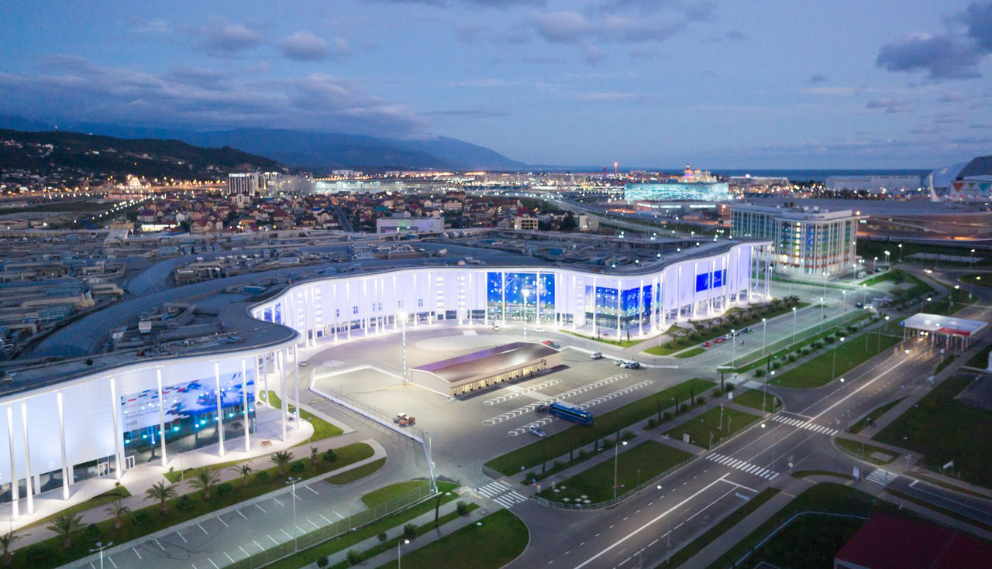

4. THE EXHIBITION HALL
Specifications for the Main Media Center complex
The booths will be put up in the Media Center Gallery and in Hall 5.5
The GALLERY
- Ceiling height in the Gallery: 12 m
- Maximum height for booths: 4 m
- Due to structural reasons, mounts MAY NOT be used
Hall 5.5
- Ceiling height in Hall 5.5: 8 m
- Maximum height for booths: 4 m
- Mounts may be used throughout the hall (distance from the walls: 1 m)
- Mounts may not be higher than 6 m at the top point of the mounted structure

Your booth must not exceed the allowed height.
(See the Space with No Equipment section, p. 7).
Timeframe for entrance and exit for installation and dismantling must be pre-approved.

Installation gate size: 2,400 × 2,500 (H × W).
Number of cars parked at the same time: 5

Pavilion floor load
Maximum allowed load for the hall floor: 1,200 kg per 1 sq.m.
The load must be distributed evenly without selective points with many heavy objects.

Exhibition venue access
Participants: IDs (badges) grant the personnel of the companies – the Forum participants access to the exhibition hall. Detailed information may be found in the Procedure for Entrance and Delivering Exhibits and Equipment section (p. 15).

Contractors: contractors must provide their employees with clean uniforms bearing distinctive emblems (badges) signifying the employee’s affiliation with a particular company, their position and full name.

No one may not be present in the exhibition hall without a badge!

Cargo delivery and removal
The procedure for delivery and removal of equipment to and from the entrance hall is described in the Procedure for Entrance and Delivering Exhibits and Equipment section of the Manual (p. 15).
Due to its location, the Main Media Center does not have space for assembling and storing construction debris and other outsized debris and packaging. Consequently, pursuant to unloading the materials and installing their exhibits, all the exhibition participants are required to remove all the packaging and construction debris using their own transportation.

Storing packaging materials in the Main Media Center during the exhibition is prohibited!

Timeframe for installing outsized and heavy equipment and exhibits must be coordinated with the Forum Directorate in advance.

Smoking is strictly prohibited throughout the Main Media Center!

5. SPACE WITH NO EQUIPMENT. FORM С1
If you rent space without equipment, you are responsible for erecting and equipping your own booth. The booth design must comply with the Forum’s rules and must be approved by the Forum Directorate, and the Exhibition participant or their contractor must obtain a permit (technical accreditation) at the Forum’s Technical Directorate to carry out installation and dismantling works. The price of technical accreditation for exclusive booths is from 40 Euro (+ 20% VAT) per 1 sq.m. of rented space, provided that the accreditation is granted with the timeframe specified by the Forum’s Technical Directorate; beyond this timeframe, surcharges apply. (Detailed information is available in the Contractor’s Memo). In addition to payments for assessing the documentation, the Technical Directorate charges a disposal fee. The amount of the fee depends on the booth area based on the rate of 13 Euro (+20% VAT) per 1 sq.m. of booth space. The Technical Directorate also ensures the fire safety (fire retardant treatment for flammable materials) and fire-safe operation of the booths (assessing the design of booths, installing fire detectors, etc.). This work is NOT COVERED by the cost of technical accreditation and is to be paid for separately. The payments are calculated individually for each booth following an examination of the design.
To keep to the timeframe for preparing, constructing and equipment exhibition booths, the contractor must study the relevant paperwork in advance. The contractor will be allowed to perform the work only on condition they sign an appropriate contract with the Forum’s Technical Directorate (Relict Stroy LLC) and make required payments.
Getting the Forum Directorate approval for the design concept
The Forum participants must have their design concepts approved by the Forum Directorate. For that purpose, they must fill out and submit Form С1 to the Forum Directorate no later than March 25, 2019. The Form must list:
- the contractor’s company name and contact details of the person in charge;
- design concept of the exhibition booth with a 3D sketch (minimum 2 views);
- plan of the booth’s every floor with a metric grid to scale;
- side view with a metric grid to scale.
In reply the Participant will be sent Form С1 with the Forum Directorate’s approval or list of changes to be made to the design concept.
Please note that if you fail to meet the March 25, 2019 deadline for submitting Form С1, further approval carries a charge of 10 Euro (+ 20% VAT) per 1 sq.m. of rented space!
If a Forum participant did not have the design concept of their booth approved by the Forum Directorate, the participant or their contractor will be denied admittance to the site to install their booth. If the constructed booth deviates from the approved design concept, the Forum Directorate has the right to suspend installation and demand that the work be done in compliance with the approved design.
IMPORTANT!
- Power connection for the booth must be requested separately based on the total power consumption of all the energy consumers; Form С5 is required.
- If the booth’s outer surface is visible from the aisles or nearby booths, it should be decorated appropriately; only neutral white is allowed: either a white banner or white fabric. It is MANDATORY that the entire height of the back surface of the booth facing the pavilion’s walls be decorated! Distance from the wall is 1.2–1.5 м.
ANY STRUCTURAL ELEMENTS (particle board, aluminum sections) MUST NOT BE VISIBLE.
None of the walls of the stand shall not be closer to the main passage closer than 1 m
- The maximum allowed booth height is 4 meters.
- Mounts may not be placed above the booths in the Gallery.
Obtaining installation permit (Technical accreditation)
The Exhibition participant or their contractor must obtain a permit to perform installation (technical accreditation) at the Forum Technical Directorate (Relict Stroy LLC). Charges apply.
Technical accreditation of contractor companies:
Technical Directorate
For any questions please contact the Head of the Technical Support Service of the Forum.

Alexander Bezgubov
alexander.e.bezgubov@gmail.com
+7 (921) 846-46-93

6. CUSTOM BOOTH INSTALLATION
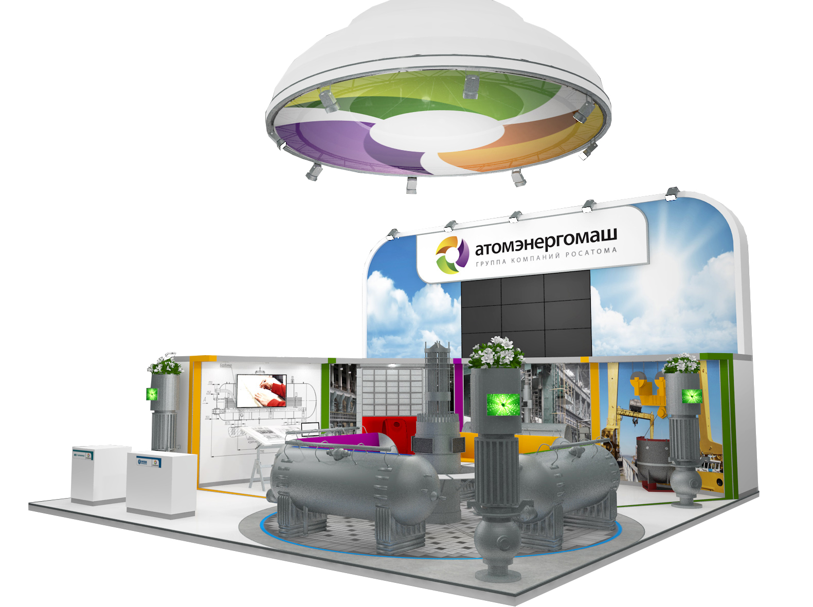
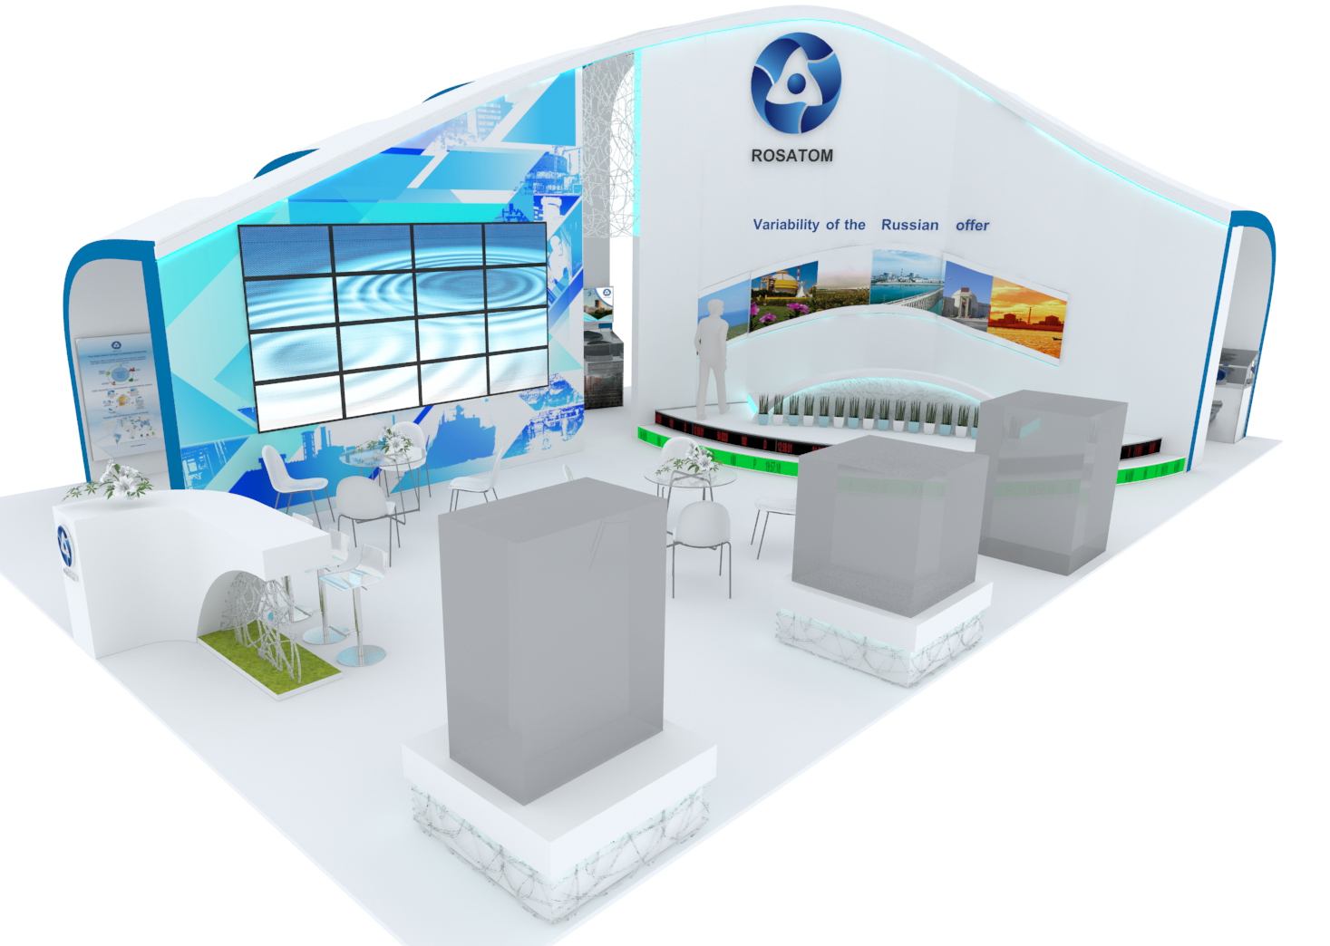

7. SPACE WITH EQUIPMENT (standard “Business” booth). FORM С2 AND FORM С3
A standard “Business” booth is constructed using light aluminum MAXIMA parts and laminated melamine board, upholstered with banners bearing the Forum’s logo; it is equipped with furniture and equipment in accordance with the size of the rented space. The height of walls is 3 meters and the height of fasciae is 4 meters. Booth plans and equipment list for standard “Business” booths are given on pp. 10-11. The fascia on the side facing the aisle will bear the company name (10 characters are included in the booth’s price). The 1.2 meter-high fascia is a white banner installed at the height of 3 meters.
Fill out Form С2 (booth plan) using the legend given and send it to the Forum Directorate. This Form and any changes therein should be sent to the Forum Directorate no later than March 25, 2019.
The equipment you have not marked on the plan will not be installed in the booth!
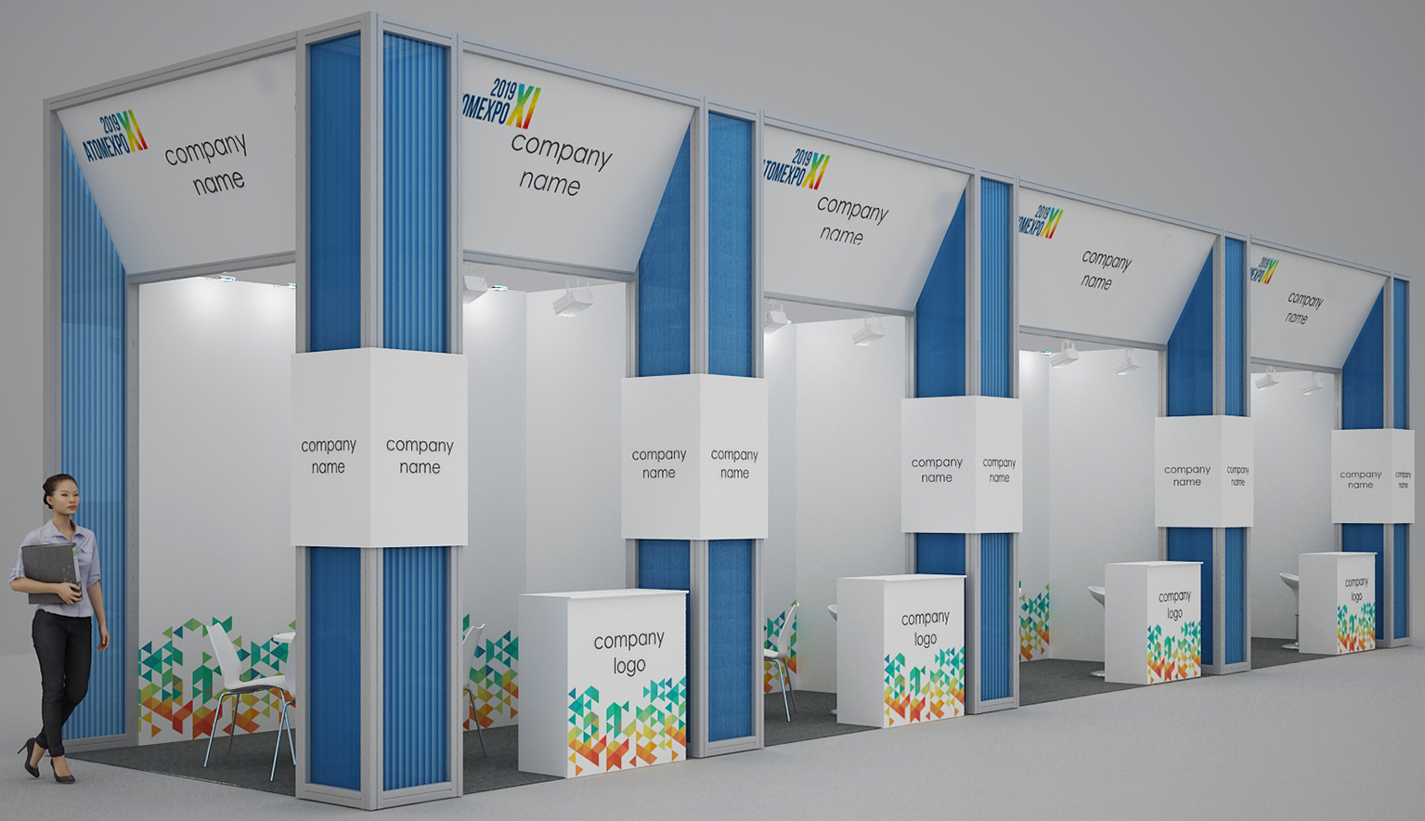
If Form С2 was not submitted, the standard “Business” booth is set up following plans on pp. 10-11. In a corner booth, open sides facing the aisle bear fasciae with the company’s name. Use Form C4 to order additional equipment. If the equipment you ordered is not in your booth at the end of the final installation day, April 13, inform the Forum Directorate.

Upon receipt of your filled-out forms, you will be sent the plan of your booth.
Keys to the doors and/or locks for filing cabinets and display windows may be received at the Forum Directorate on the day of your arrival (10 Euro deposit per unit required).
During installation, the booths that have been installed and decorated are not to be independently altered, no full or partial dismantling is to be performed by the Forum participant.
Wall elements, any other elements of the booth, supply closets, or furniture that are ordered and received by the Forum participants are to be returned undamaged and clean of any scotch tape, glue, etc.
No holes may be drilled, no equipment may be brought in by the participant to be attached to the rented or adjacent booth elements and supply closets using self-tapping screws, nails, pins, tacks, glue, scotch or duct tape, etc. The Forum participant will be billed for the price of damaged elements of the booth, hall, and equipment.

ATTENTION!
Power connection for the booth must be requested separately based on the total power consumption of all the energy-using equipment; Form С5 is required.

8. SAMPLE PLAN AND EQUIPMENT FOR A STANDARD “BUSINESS” BOOTH
The section contains samples of booths and the list of equipment per the size of the rented area. If the booth area is greater than listed in the Manual, the equipment is calculated from two booths of appropriate area.
Draft a plan of your booth in Form С2 using the legend and the examples below. You may make changes by moving walls, doors, electric plugs, lights, and furniture. Sample equipment and furniture may be found on p. 24.
The company name will be inscribed on the booth’s fasciae facing the aisles. In Form С3, state the name of your company to be put on the fascia taking into account the number of inscriptions required for a corner- or peninsula-shaped booth. You may also use Form С3 to order additional graphic design for your booth.
9 sq.m. booths
- Gray carpeting
- Walls along the closed sides
- Decorative pillar
- Supply closet with a folding door: 1 sq.m.
- Information counter
(laminated particle board): 1
- Barstool: 1
- Round table (D 70 cm): 1
- Chair: 4
- Metal halide flood light: 2
- Bar-mounted halogen flood light: 2
- Euro plug: (three outlets, 1 kW, 220V): 1
- Company name: 10 characters
- Wall-mounted clothes hanger: 1
- Waste paper basket: 1
12 sq.m. booths
- Gray carpeting
- Walls along the closed sides
- Decorative pillar
- Supply closet with a folding door: 1 sq.m.
- Information counter
(laminated particle board): 1
- Barstool: 1
- Round table (D 70 cm): 1
- Chair: 4
- Metal halide flood light: 3
- Bar-mounted halogen flood light: 3
- Euro plug: (three outlets, 1 kW, 220V): 1
- Company name: 10 characters
- Wall-mounted clothes hanger: 1
- Waste paper basket: 1

15 sq.m. booths
- Gray carpeting
- Walls along the closed sides
- Decorative pillar
- Supply closet with a folding door: 2 sq.m.
- Information counter
(laminated particle board): 1
- Barstool: 1
- Round table (D 70 cm): 1
- Chair: 4
- Metal halide flood light: 4
- Bar-mounted halogen flood light: 4
- Euro plug: (three outlets, 1 kW, 220V): 1
- Company name: 10 characters
- Wall-mounted clothes hanger: 1
- Waste paper basket: 1
18 sq.m. booths
- Gray carpeting
- Walls along the closed sides
- Decorative pillar
- Supply closet with a folding door: 2 sq.m.
- Information counter
(laminated particle board): 1
- Barstool: 1
- Round table (D 70 cm): 1
- Chair: 4
- Metal halide flood light: 5
- Bar-mounted halogen flood light: 5
- Euro plug: (three outlets, 1 kW, 220V): 1
- Company name: 10 characters
- Wall-mounted clothes hanger: 1
- Waste paper basket: 1
Стенд 9 кв.м. (угловой) | 9 sq.m. booth (corner)
Стенд 9 кв.м. (линейный) | 9 sq.m. booth (linear)
Стенд 12 кв.м. (угловой) | 12 sq.m. booth (corner)
Стенд 12 кв.м. (линейный) | 12 sq.m. booth (linear)
Стенд 15 кв.м. (угловой) | 15 sq.m. booth (corner)
Стенд 15 кв.м. (угловой) | 15 sq.m. booth (linear)
Стенд 18 кв.м. (угловой) | 18 sq.m. booth (corner)
Стенд 18 кв.м. (линейный) | 18 sq.m. booth (linear)
Название компании | Company name
Стул | Chair
Стол | Table
Стул барный | Barstool
Инфостойка | Information counter
Вешалка | Clothes hanger
Корзина | Basket

Booths larger than 18 sq.m.
Equipment for booths larger than 18 sq.m. is calculated as a sum of equipment for an 18 sq.m. booth and a smaller booth from the list above.
There is one laminated chipboard information counter and one bar stool in a booth of any size.

9. GENERAL INFORMATION FOR ALL TYPES OF BOOTHS
Booth and hall elements, equipment
No parts of the booth, sign, or other equipment must protrude beyond the area specified in the contract. The Forum Directorate reserves the right to remove such elements and parts of the booth at the expense of the Forum participant.
Location
Electric cabinets, points for utility connections for your and adjacent booths may be located within your exhibition area. In this case, power cables may be installed in the aisles or within your booth without additional coordination. Please make a note of it, particularly when planning to install flooring and/or daises within your booth. For additional information, please contact the Forum Directorate.
Sub-exhibitors
Sub-exhibitors’ participation is allowed only provided they comply with the rules of participation in the Forum, consequently, provided they pay the participation fee and Official Catalog listing fee. See Form С9.
Noise level
When holding presentations, video- and audio-demonstrations, the noise level must not exceed 80 decibels (the noise made by a truck engine) at the booth’s outer edge. Should other Forum participants complain of excessive noise, the Forum Directorate has the right to cut off the source of the noise.
Banners, flags, balloons
No advertising structures (banners, flags, etc.) may be located on the floor, hall elements, walls, and other hall locations without the permission of the Forum Directorate. When using balloons and garlands to decorate the exhibition or to advertise, light gas must not be used to avoid the balloons going up to the ceiling.

10. GENERAL AND ADDITIONAL SERVICES
Form No. 3 (application for service). Payments. Late orders
Form No. 3 (Addendum No. 1 to the Exhibition Participation Contract, p. 18), and application forms should be submitted to the Forum Directorate no later than March 25, 2019.
Services ordered must be paid for immediately upon receiving the invoice. Without payment, orders will not be processed for fulfillment. All prices in the Manual are listed without 20% VAT.
ATTENTION!
Orders placed between March 26 and April 3 will be fulfilled with a surcharge of 50%, orders placed between April 4 and 14 and later (during the Forum) will carry a surcharge of 100% provided their fulfillment is feasible. When an order is placed during the Forum, some services and equipment may be no longer available.
Orders will not be accepted for consideration without Form No. 3 filled out, signed, and stamped with the company’s seal; orders will not be accepted for fulfillment without invoice payment.
The booth’s fascia. Graphic design. Form С3
The standard “Business” construction includes putting the company’s name (up to 10 characters) on the booth’s fascia. Put your company’s name on Form С3 and submit it to the Forum Directorate. If you need more than 10 characters, you will need to order manufacturing and installation of additional characters using the same form and taking into account the number of fasciae.
In addition, you may use Form С3 to order printing banners for your walls, covering equipment surfaces in the booth with colored film and putting your logo on the fascia and other booth elements (an additional information counter, daises, walls, etc.). Please indicate the colors of your logo and send a vector image (*.cdr, *.ai or *.eps) to the Forum Directorate marking the place where the logo is to be put on the booth’s plan (Form С2).
Form С3 may only be used to place orders for space with equipment.
Structural elements, furniture, and electric equipment. Form С4
Additional elements of the booth’s structure, furniture and equipment, lighting fixtures, plugs, kitchen appliances, audio, video, and other equipment may be ordered using Form С4, pp. 22-23. Please mark required items on the order form and indicate on the booth’s plan in Form C2 places to put the equipment.
Form С4 may only be used to place orders for space with equipment.
Power connection. Form С5
Power connection for the booth is not included in the cost of renting the exhibition space rent; it needs to be ordered separately (based on the total power consumption) using Form С5.
For booths with no equipment, power connection is done independently by the Forum participant or their contractor. The Forum participant or their contractor must have their own electric service panel and lead-in feeder cable at least 40 meters long.
Connecting the booths to the power grid is done during the Forum. During installation and dismantling, the Forum participant or their contractor must use battery-powered tools. The number of plugs in the hall is limited.

Booth cleanup. Internet connection. Security. Form С6
The aisles between the booths will be cleaned every morning during the Forum. To have the garbage you accumulated during the day picked up, collect the garbage and put it out in into the aisle at the end the day. Use a plastic bag or a box. Maintaining the cleanliness of the booth is the responsibility of the Forum participant. You may use Form С6 on p.26 to order individual cleanup of your booth.
You may use Form С6 to order internet connection for your booth. Cables are used. You may order additional equipment for Wi-Fi internet connection. Please mark the entrance point for the cable and places for putting the equipment on the booth’s plan (Form С1 for space with no equipment, Form С2 for space with equipment).
Forum participant’s ID. Invitations to the Gala Dinner. Form С7
The Forum participants are issued Forum participant ID (badge) at the rate of 2 free IDs per each full (!) 9 sq.m. of the booth’s area, and invitations to the Gala Dinner at the rate of 1 free invitation per company (Form С7, p. 27).
Each staffer working at the booth must be accredited (registered); they must wear their personal badge to enter the exhibition hall. The badges are not transferrable. Sub-exhibitors may be present at a booth, but they must comply with general terms for participation in the Forum and they must pay the set registration fee.
Registration is held:
- in the Sochi airport and in the lobby of Radisson, Omega Sirius Park, and Imeretinskaya 4* hotels
- in the entrance area of the Main Media Center
If you need additional Forum participant’s IDs or invitations to the Gala Dinner, you may order them by filling out Form С7, p. 27.
If you employ additional staff, please make sure all your company’s personnel manning the booths during the Forum, installation and dismantling work have badges and are on the “Letter for the Access of Employees for Assembly/Dismantling” (see section “Procedure for Entrance and Delivering Exhibits and Equipment,” p.15)
Advertising in the Forum’s Official Catalog. Additional advertising opportunities. Form С9
You may use Form 9 to order additional advertising for your company in the Forum‘s Official Catalog, such as your logo next to the company’s description or a full-page advertisement. The same form may be used for additional advertising opportunities.
Advertising materials for the Official Catalog should be submitted to the Forum Directorate no later than March 25, 2019.
For offers for Sponsors, and to inquire about the price and contents of the Sponsor package, contact the Forum Directorate.
11. RULES FOR ASSEMBLY / INSTALLATION AND DISMANTLING
The Forum participant or their contractor must provide their employees with clean uniforms bearing distinctive emblems (badges) signifying the employee’s affiliation with a particular company and full name.
No one may be present at the exhibition hall without a badge!
To ensure compliance with labor and health safety and to ensure free access to the booths during the installation and dismantling of the exhibition, the removal of accumulating garbage either as it accumulates, or immediately upon a request of the Forum Directorate is the responsibility of contractors or the Forum participants.
Pursuant to unloading the materials and installing their exhibits, all the Forum’s exhibition participants or their contractors are required to remove all the packaging and construction debris using their own transportation.
All the work on setting up a Forum participant’s exhibition booth must be completed by 18:00 on April 13, the final day of the Forum’s installation work.
IMPORTANT:
Please note: no extensions of installation work on April 13 will be granted!!!

All installation work must comply with the current safety regulations, regulations for operating consumer power units, power unit installation safety, fire safety in the Russian Federation, and the construction rules and regulations.
Prior to starting the work, all employees of contractor companies must attend a training session conducted by representatives of the Forum Technical Directorate
Painting during booth construction may be done only if the floor is covered with plastic sheets (no less than 1 meter around the booth). Only water-based paints and materials may be used. Should paint get on the surfaces of other booths or of the hall, removing it is the responsibility of the Forum participant or their contractor.
Work that results in construction dust may only be performed using dust collectors. On April 13, the final day of installation work, absolutely no work resulting in construction dust may be performed.
During installation of the Forum’s exhibition booth and upon its completion, the Forum participant or their contractor are responsible for removing all the packaging, remains of construction and installation materials, all the exhibition debris of the principal and auxiliary construction and installation materials, construction debris, and solid municipal waste from the Main Media Center.
Storing packaging materials in the Main Media Center during the Forum is prohibited.
On April 16, the Forum’s final day, all dismantling work is PROHIBITED until 23:00
(delivering packaging to the booth, packing and removing exhibits, access for construction workers)
Work on dismantling the booth may start only after 23:00; the aisles must be covered with particle board before dismantling begins.
When the Forum ends and the exhibition is dismantled, full removal of all the structural elements and the construction debris is the responsibility solely of the Forum participant or their contractor. When the carpeting is removed, the Forum participant or their contractor must clean the floor of the duct tape used to install the carpeting and to leave the exhibition space clean for the representatives of the Forum Directorate and the administration of the Main Media Center.
The Forum participants, their representatives and their contractors are fully responsible for any damage their action or inaction caused to the space or property of the Forum’s venue and of other event participants.
12. PROCEDURE FOR ENTRANCE AND DELIVERING EXHIBITS AND EQUIPMENT

To enter the venue during the assembly / dismantling period, you must have the following:
- a vehicle pass;
- an installation pass or a driver’s badge;
- a consignment note with a list of the materials and equipment required for the construction of the exhibition/booth indicating the name of the company for which the exhibition/booth is being built. The delivery slip must be certified by the senior official of the company.

You must complete a consignment note in three copies for the removal of equipment in order to obtain an entry/exit permit from the Exhibition site during the assembly/dismantling period. A sample consignment note is given on the last page of the manual.

If necessary, a contractor shall be required to present its vehicle for inspection at the checkpoint.

Rules for the completion of Consignment Notes for equipment removed from the Exhibition venue:
- Consignment Notes (CN) are only completed for loaded vehicles. A separate CN must be filled out for each vehicle.
- The person responsible for the removal of a contractor’s equipment from the Exhibition venue must indicate the name of the organization of the consignor and the consignee in the heading.
- The consignor and the consignee are the contracting company unless otherwise specified. The form of incorporation and name of the organization must be entered in the appropriate lines.
- The vehicle on which the equipment is removed must be indicated in the upper right part of the CN: the make, model, and the driver’s name.
- All columns must be completed in the information table about the material items being removed.
- The “Release permitted” lines must indicate the position of the employee of the Forum’s Technical Directorate Relict Stroy LLC who signs off on the correctness of the entries and permits the shipment of the goods to the consignee.
- The “Cargo released by” line must indicate the position of the representative of the contractor responsible for the removal of the equipment along with the signature and seal of the contracting organization.
- The date of the preparation of the CN must be indicated below.

A sample of the Consignment Note is given on the last page of the Manual.
A sample of the Material Pass for the Removal of Material Items
(from the Talent and Success Foundation) is attached to the Manual as a separate file.
13. SAMPLE LETTER FOR ENTRY FOR ASSEMBLY/DISMANTLING
Sample letter for the delivery and removal of exhibits and equipment
This letter DOES NOT constitute a pass for the delivery/removal of exhibits and equipment to the territory of the Main Media Centre. The completed letter must be sent to the Forum Directorate prior to 15:00 on March 25, 2019. You must have the original letter with you upon arrival.
To be completed on the organization’s letterhead
(in THREE copies)

To: ATOMEXPO LLC
Director of the 11th International Forum ATOMEXPO 2019
Dmitry Shabinskiy

(company name)
(address)

Please permit the DELIVERY/REMOVAL of exhibits, equipment, and materials, which will be presented at Booth No. _____ on the territory of the Main Media Centre during the 11th International Forum ATOMEXPO 2019.

List of exhibits and equipment:
No. | Name* | Quantity
1
2
3
4
5
Add lines if necessary
* The total number of packages (boxes) must be indicated when delivering consumables, promotional products, food products, etc.

We guarantee the removal of the delivered equipment, exhibits, packaging, large-sized packaging, and materials of the exhibition stand structures in a timely manner.

Position
seal here | (Signature) | (Full name)
14. SAMPLE LETTER FOR THE ACCESS OF EMPLOYEES FOR ASSEMBLY/DISMANTLING
This letter DOES NOT constitute an access pass for employees of a company involved in assembly/dismantling to enter the territory of the Main Media Centre during the assembly and dismantling of the Forum. The completed letter must be sent electronically (SCAN !!!) to the Forum Directorate by email: atomexpo@atomexpo.com by 15:00 on March 25, 2019. You must have the original letter with you upon arrival. In the event of any changes to staff, you must contact the Forum Directorate to make additions to the list of employees.
A Microsoft Excel file structured as following must be attached to the letter:
For citizens of the Russian Federation
№ | Surname | First name | Patronymic | Position | Date of birth | Place of birth | Passport series and number, date of issue, issuing authority
1 | 2 | 3 | 4 | 5 | 6 | 7 | 8
1
For foreign citizens
№ | Surname | First name | Patronymic | Position | Date of birth | Place of birth | Passport series and number, date of issue, issuing authority | Full name in Latin letters | Citizenship
1 | 2 | 3 | 4 | 5 | 6 | 7 | 8 | 9 | 10
1

To be completed on the organization’s letterhead
(in THREE copies)
To: ATOMEXPO LLC
Director of the 11th International Forum ATOMEXPO 2019
Dmitry Shabinskiy
(company name)
(address)

Please grant access to the following employees for the assembly and dismantling of equipment at Booth No. _____ on the territory of the Main Media Centre at the 11th International Forum ATOMEXPO 2019.

List of employees:
No. | Full name
1
2
3
4
5
6
7
8
9
Add lines if necessary

Position
seal here | (Signature) | (Full name)

Appendix No. 1
to Contract No.
dated |  |  |  |  | 20
Form No. 3 APPLICATION FOR ADDITIONAL SERVICES AND EQUIPMENT
Please submit form to the Forum Directorate by fax: +7 (499) 922-89-95; email a SCAN to: atomexpo@atomexpo.com

Organizer: |  |  | ATOMEXPO LLC
Exhibition participant:
 |  |  | (Full legal name of the company)
As represented by:
 |  |  | (Position, Full name)
Acting on the basis of:
Contact name:
 |  |  | (Full name)
Tel.: |  |  |  | Fax: |  | E-mail:

Participant requests the following services:

Form No. | Name of service: |  | Sum, Euro:
Form С3 | Inscription on the fascia. Graphic design
Form С4 | Additional equipment
Form С5 | Power connection
Form С6 | Cleaning, internet, security
Form С7 | Badges, invitations
Form C8 | Company description (Catalog) and additional advertising opportunities
Form С9 | Loading/unloading
 | Total:
 | Surcharge for late order (from March 26 to April 3, 2019): 50%
 | Surcharge for late order (from April 4 to 16, 2019): 100%
Form С1 | Approval of booth design concept after March 25, 2019
 | Total including extra charge for late order and Form С1:
 | 20% VAT:
 | Total with 20% VAT:
Written amount:

The cost of additional services provided by the Organizer to the Participant is determined in accordance with the forms established by the Participant's Manual to the 11th International Forum ATOMEXPO 2019. After signing this application, the additional services and equipment ordered may be cancelled no later than March 13, 2019. In the event that additional services and equipment are cancelled after the expiration of the above-mentioned period, funds shall not be subject to refund.
The participant has carefully read the rules of exhibition participation set forth in this Manual and agrees to them.

Organizer: |  |  |  |  |  |  |  | Participant:
ATOMEXPO LLC
Position: |  | Executive Director |  |  |  |  |  | Position:
Signature: |  |  |  |  | /Shingaryov N. E./ |  |  | Signature: |  | /
 | seal here |  |  |  |  |  |  |  | seal here |  |  |  | (Full name)
FORM  С1 |  |  | SPACE ONLY  FORM MUST BE FILLED OUT  Only for participants ordering space  To be submitted before March 25, 2019

Please submit form to the Forum Directorate by fax: +7 (499) 922-89-95; email: atomexpo@atomexpo.com

Company |  | Booth No.

Attention!
If you are ordering the construction of an exhibit booth structure through the Forum Directorate, you do not need to fill out this form

Please submit the following information concerning the company responsible for the construction to the Forum Directorate:

Construction company name:
Contact name:
Contact telephone number:

And the final booth design concept, containing:

- Exhibit booth design concept with 3D sketch (from at least three perspectives);
- The plan for each floor of the booth structure with a scale of 1 m;
- A side view with a scale of 1 m;

Please place a 3D sketch of your booth in this area
and submit the other required plans and layouts of the booth in separate files.

In response you will be sent a C1 Form with a note from the Forum Directorate for the approval of the booth design or an indication of changes to be made thereto.

Design concept approval after March 25, 2019

In case of failure to meet the deadline for submitting Form C1 before March 25, design concept approval for a booth shall be granted for a fee of 10 Euro per square meter of rented space.

Name | Cost, Euro per m²  without 20% VAT | size, m²: | sum:
Approval of design concept for exhibit booth structure after 25 March, 2019 | 10

Attention!
If a Forum participant has not passed the procedure for approving the design concept of their booth, they or the company responsible for the construction of their booth structure shall not be allowed onto the site of the exhibition for the purpose of booth installation.

TOTAL FOR FORM С1: |  | Euro
Invalid without Form No.3!

Full name: |  |  | Signature |  | Date
FORM  С2 |  | EQUIPED BOOTH (BOOTH OUTLINE)  FORM MUST BE FILLED OUT  Only for participants ordering equipped space  To be submitted before March 25, 2019
Please submit form to the Forum Directorate by fax: +7 (499) 922-89-95; email: atomexpo@atomexpo.com

Company |  | Stand No.
Make a sketch of your booth using the legend. Designate all equipment included within booth floor space as well as any additional. Examples of schemes and booth content presented on pages 10-11, and examples of furniture and equipment on page 24. Please indicate name of company on booth fascia in Form С3.
Legend:
Equipment included in the standard “Business” booth, in accordance with area size, pages 11–12:
Fascia with company name
Information desk
(laminated chip board)
Table
Chair
Wastebasket
Chair
for the bar
1.0 kW
220 V
Additional equipment
Table
Display platform table
File cabinet
File cabinet
Low display window
High display window
Stand
(3 shelves)
Radial informatino desk
TV stand
Arm-
chair
Two set
sofa
Coffee
table
Booklet holder (A4)
Cool
Coffee
Refrige-
rator
Table
glass

Scale: 1 box – 1 metre

FORM  С3 | INSCRIPTION ON THE FASCIA. DECORATIVE APPEARANCE.  FORM MUST BE FILLED OUT  Only for participants ordering equipped space  To be submitted before 25 March 2019
Please submit form to the Forum Directorate by fax: +7 (499) 922-89-95; e-mail: atomexpo@atomexpo.com

Company |  | Booth No.

Standard construction includes placement of your company name on each fascia located on the open side of the booth (see the Shell Scheme section) in the amount of 10 characters on each board. Also included in the standard is the placement of your company name on the decorative element of laminated particle board on the standard “Business” booth pillars.

Please print:

If the number of characters on your Fascia exceeds 10, please order the preparation and placement of additional characters with consideration for the number of inscriptions (fascia elements) in the case of angular placement or peninsular arrangement. You may additionally order the production and placement of company logos on the fascia and other parts of the booth, covering other parts of the booth with colored film, the development of design model, and the production and installation of banners and full-color printing on the walls of the booth.

No. | Name |  |  | Cost, Euro without 20% VAT | Quantity: |  | Amount:
1. | Preparation and placement of additional character on the booth fascia |  |  | 4
Production and placement of logos*
2. | On the fascia |  |  | 75
3. | On the information counter, table-podium, or wall. Plain* |  |  | 115
4. | On the information information counter  (laminated particle board): 1, table-podium, or wall. Multicolored* |  |  | 195
Covering parts of the booth with colored film and full-color printing
5. | Covering with colored film |  | **, sq.m. | 30
6. | Covering with full-color printing, sq.m. |  |  | 65
Production and installation of banners on the booth wall
7. | Рlacement of model on wall banners, sq.m. |  |  | 65
Development of design model for banners or full-color printing
8. | Development of design model, sq.m. |  |  | 95
 |  |  |  | Total cost:

* Please send files with logo model in vector format (*.cdr, *.ai or *.eps) by email to atomexpo@atomexpo.com and indicate the place of its application on the sketch of the booth (Form С2).
** Choose film color in series 641 at the following link https://www.orafol.com/gp/europe/en/products/colour-films-product-details/items/oracal-641-economy-cal
TOTAL FOR FORM С3: |  | Euro
Invalid without Form No.3!

Full name: |  |  | Signature |  | Date
FORM  С4 |  | ADDITIONAL EQUIPMENT  Only for participants ordering equipped space  To be submitted before March 25, 2019

Please submit form to the Forum Directorate by fax: +7 (499) 922-89-95; email: atomexpo@atomexpo.com

Company |  | Booth No.

Samples of furniture and equipment are shown on page 24. Specify the location of the equipment ordered on the booth sketch in Form С2. Please do not re-order the equipment that is already included in your booth.
Equipment orders placed between March 26 and April 3, 2019 shall be accepted subject to availability and carry a 50% surcharge, and orders placed between April 4 and 16, 2019 carry a a surcharge of 100%.

No. | Name | Cost, Euro without 20% VAT | Quantity: |  | Amount:
Parts of booth structure
1. | Wall features (banner with Forum logo) L-1.0m, H-3m | 72
2. | Wall features (banner with Forum logo) L-0.5m, H-3m | 55
3. | Double-leaved door/folding door | 140
Furniture
10. | Soft chair (black faux leather, chrome legs) | 32
11. | Barstool | 55
12. | Square table 0.7 × 0.7 m | 55
13. | Rectangular table 1.2 × 0.6 m | 70
14. | Round table D-0.7 m | 62
15. | Round glass table D-0.7 m | 95
16. | White armchair | 80
17. | Two seat sofa | 140
18. | Glass coffee table 0.9 × 0.5 m, H-0.45 m | 55
19. | Laminated particle board information stand 1 × 0.5 m, H-1 m | 215
Furniture out of structural elements and other accessories
20. | Information counter 1 × 0.5 m, H-1 m | 145
21. | Information counter, radial R-0.5 and 1m, H-1 m | 245
22. | Table-podium (closed on 3 sides) 1 × 0.5 m, H-0.7 m | 80
23. | Filing cabinet (low) 1 × 0.5 m, H-0.7 m | 110
24. | Filing cabinet (high) 1 × 0.5 m, H-1 m | 145
25. | Television stand 0.5 × 0.5 m, H-1 m | 100
26. | Low show-case 1 × 0.5 m, H-1 m | 160
27. | High illuminated show-case 1 × 0.5 m, H-2.5 m  2 glass shelves | 260
28. | Stand, 3 shelves 1 × 0.5 m, H-2.5 m | 98
29. | Holder for reading material (booklet holder) 4 × А4 | 68
30. | Hanger for clothes (freestanding) | 20
Form С4 is continued on the next page
Continuation of Form С4

Electrical fixtures
40. | Shaft halogen lamp / bar spotlight 150W | 110
41. | Luminescent lamp (LDS) 40W | 55
42. | Metal halide floodlight 150W | 160
43. | Triple outlet, 220В up to 1 kWh | 42
44. | Triple outlet, 220В up to 2.5 kW | 52
45. | Power outlet, 380В/16А up to 10 kW | 180
46. | Power outlet, 380В/32А up to 20 kW | 235
Kitchen appliances
60. | Cooler with water bottle (19L) | 145
61. | Additional cooler with water bottle (19L) | 37
62. | Refrigerator (with a 24 hour outlet) 80L | 140
63. | Coffee machine, capsule type (50 capsules) | 250
64. | Capsules for coffee machine (50 capsules) | 75
Audio-visual equipment
70. | LCD television (HDMI, USB)* diagonal 47" | 460
71. | LCD television (HDMI)* diagonal 50" | 525
72. | Freestanding LCD TV / plasma display panel stand | 140
73. | Wall mounting LCD ТV / plasma display panel | 140
74. | DVD-player | 60
75. | Laptop | 230
 |  | Total cost:

* – If you order an LCD television and bring your own signal source, please
INDICATE SO BELOW (Х):

Own laptop |  |  | Own DVD |  |  | Own USB-flash card

TOTAL FOR FORM С4: |  | Euro
Invalid without Form No.3!

Full name: |  | Signature |  | Date
EXAMPLES OF FURNITURE AND ADDITIONAL EQUIPMENT

Chair  10 | Barstool  11 | Square table  12 | Rectangular table  13 | Round table  14 | Round glass table  15
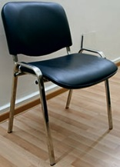 |  | 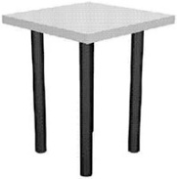 | 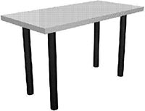 | 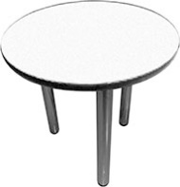 | 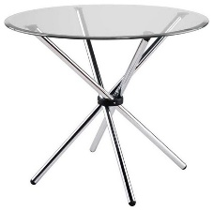
White armchair  16 | Two seat sofa  17 | Glass coffee table  18 | Laminated particle board information stand 19 | Information counter  20 | Radial counter stand  21
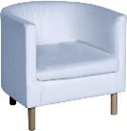 | 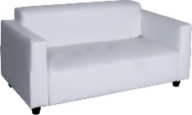 | 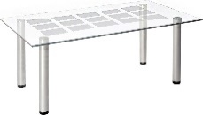 | 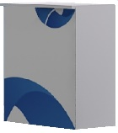 | 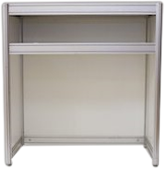 | 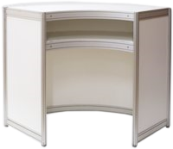
Table-podium  22 | Filing cabinet  low  23 | Filing cabinet  high  24 | TV Stand  25 | Show-case low  26 | Show-case high  27
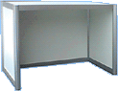 | 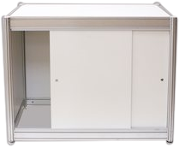 | 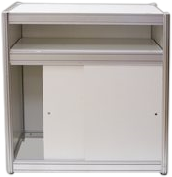 | 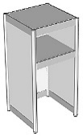 | 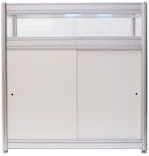 | 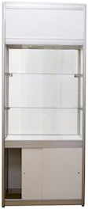
Stand  28 | Booklet holder  29 | Freestanding hanger  30 | Shaft halogen lamp  40 | Metal halide floodlight  42 | Triple outlet  43/44
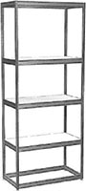 | 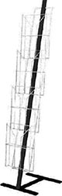 | 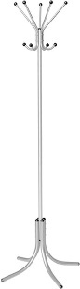 | 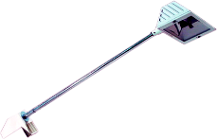 | 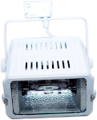 | 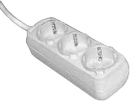
Power outlet  45/46 | Cooler with water bottle  60 | Refrigerator  80L  62 | Capsule type coffee machine  63 | LCD ТV 47”  70 | Plasma display panel 50”  71
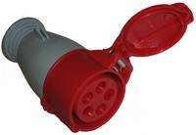 | 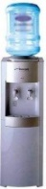 |  | 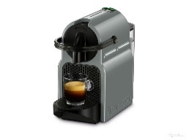 | 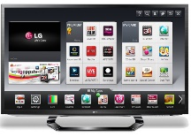 | 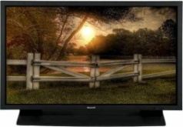
Floor stand  72 | DVD player / laptop  74/75
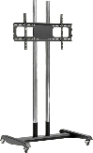 | 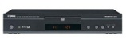

Form  С5 | CONNECTION AND CONSUMPTION OF ELECTRICITY  FORM MUST BE FILLED OUT  For all Forum participants  To be submitted before March 25, 2019

Please submit form to the Forum Directorate by fax: +7 (499) 922-89-95; еmail: atomexpo@atomexpo.com

Company |  | Booth No.
An electrical connection for the booth is not included in exhibition space rent and is mandatory and based on the installed capacity of all energy consumers.
Please ensure that you have ordered the right capacity, adding up the power consumption of all electrical appliances at the booth, connected and intended for connection.

No. |  | Capacity* | Cost, Euro without 20% VAT | Number of connections: | Amount:
For equipped space (standard booth)
1. | Up to 2 kW |  | 235
2. | Up to 5 kW |  | 310
3. | Up to 10 kW |  | 375
4. | Up to 15 kW |  | 485
For unequipped space
5. | Up to 5 kW |  | 340
6. | Up to 10 kW |  | 395
7. | Up to 20 kW |  | 550
8. | Up to 30 kW |  | 985
 |  |  | Total cost:

* The service rate includes the cost of electricity consumption (expenditure).
** For unequipped booths, the electricity supply to the booth is carried out by Forum participants or their developer companies independently; the builder of the booth must supply own electrical panel and power cable (minimum 40 linear metres).
If you need to connect more than 30 kW of power, you need to install
a second electrical panel and pay for additional electrical connection.

TOTAL FOR FORM С5: |  | Euro
Invalid without Form No.3!

Full name: |  | Signature |  | Date

FORM  С6 | CLEANING, INTERNET, SECURITY  For all Forum participants  To be submitted before March 25, 2019

Please submit form to the Forum Directorate by fax: +7 (499) 922-89-95; email: atomexpo@atomexpo.com
Company |  | Booth No.

Booth cleaning
No. | Name | Cost, Euro without 20% VAT | Quantity: | Amount:
1. | Full-service booth cleaning, morning April 15, for 1 sq.m | 5
2. | Full-service booth cleaning, morning April 16, for 1 sq.m | 5
3. | Daily full-service cleaning, for 1 sq.m | 9
 |  | Total cost:
Full-service cleaning includes vacuuming the floor of the booth, emptying the waste paper baskets, and removing garbage, as well as a wet cleaning of the surfaces of tables, information stands, etc.
Daily cleaning is to be carried out once a day in the morning from 08:00 to 09:00. To remove garbage accumulated during the day, please collect it and set it out at the end of the Forum working day, after 18:00, in the passage next to the booth in a plastic bag or a cardboard box.

Connecting to the internet
Upon ordering an internet connection, the forum participant is provided with a cable (RJ 45 connector). You may also, however, order installation and configuration of equipment for a wireless internet connection (Wi-Fi).

No. | Name | Cost, Euro without 20% VAT | Quantity: | Amount:
1. | Internet with a connection speed of 1 MB/s | 230
2. | Internet with a connection speed of 2 MB/s | 355
3. | Internet with a connection speed of 5 MB/s | 480
4. | Internet with a connection speed of 10 MB/s | 620
4. | Internet with a connection speed of 20 MB/s | 750
5. | Installation and configuration of equipment for a wireless Internet connection (Wi-Fi). | 200
 |  | Total cost:

Booth security
Unarmed booth security may be provided during the exhibition period from April 15 to 16 (from 09:00 to 19:00). The security costs 25 Euro per hour.

No. | Date of security provision |  | Time of security provision | Cost, Euro without 20% VAT | Number of hours: | Amount:
1. | April 15 |  |  | 25
2. | April 16 |  |  | 25
 | Total cost:

TOTAL FOR FROM С6: |  | Euro
Invalid without Form No.3!

Full name: |  | Signature |  | Date

Form  С7 | BADGES, INVITATIONS  FORM MUST BE FILLED OUT  For all Forum participants  To be submitted before March 25, 2019

Please submit form to the Forum Directorate by fax: +7 (499) 922-89-95; email: atomexpo@atomexpo.com
Company |  | Booth No.

Forum participant certificate (badges)
Every employee working at the booth must be registered and wear a badge to pass through to the exhibition hall. The badge cannot be transferred to another person. Pre-registration will be carried out from 08:00 to 20:00 on April 13 and 14 in the arrivals hall of Sochi Airport, in the foyer of Radisson Congress Hotel, Omega Sirius Park Hotel, and Imeretinsky Hotel4* , and from 14:00 to 18:00 on 14 April, 2019 at the stands located at the checkpoint in front of the entrance to the Main Media Center (left side).
Forum participants are provided with the participant certificates (name tags) free of charge, 2 certificates per 9 sq.m. If you need additional certificates, you can order them on this Form by filling out the table. The cost of a participant certificate is 30 Euro (+ 20% VAT).
Please fill in the table for employees working at the booth, excluding those responsible for booth construction.
No. | Full name of employee
1.
2.
3.
4.
5.
6.
7.
Total: |  | Items
Total additional participant certificates: |  |  | 30 Euro × |  | items = |  | Euro

If there is not enough space in the table, add lines, or attach an additional sheet.
Reception invitations
The Forum Directorate invites participants of the Forum to the Gala Dinner, dedicated to the opening of the 11th International Forum ATOMEXPO 2019. Information on the event venue shall be communicated to participants individually by email. One free complimentary ticket to the Gala Dinner shall be supplied to Forum participants per company. Additional invitations can be ordered with this Form by filling out the table below. The cost of an additional invitation ticket for the Gala Dinner is 300 Euro (+ 20% VAT).

The exhibition participant orders additional invitations to the Gala Dinner: | 300 Euro |  | items = |  | Euro

Invitations for exhibition guests

You must supply your guests with invitations so that they may attend the exhibition for free. Every forum visitor is required to register on the day of the Forum visit at the registration desks located in the lobby in the hall in front of the Forum, where they can receive their Visitor badges. Each participant shall receive 2 free invitations per 3 sq.m. of exhibition space. Invitations must be received from the office of the Forum Directorate before March 29, 2019 at the following address:
115419, 11/40 Ordzhonikidze Street, Moscow
 |  | TOTAL FOR FROM С7: |  |  | Euro
 |  | Invalid without Form No.3!
Full name: |  | Signature |  | Date

FORM  С8 | COMPANY DESCRIPTION IN THE OFFICIAL ELECTRONIC FORUM CATALOGUE  ADDITIONAL ADVERTISING OPPORTUNITIES  FORM MUST BE FILLED OUT  For all Forum participants  To be submitted before March 14, 2019

Please submit form to the Forum Directorate by email to atomexpo@atomexpo.com or to your manager.
Company |  | Booth No.

Information in the Official Forum Catalogue of up to 60 words is included in the registration fee, provided that you submit your information on this form in a timely manner.

Additional advertising opportunities
№ |  | Option: | Cost, Euro, 20% without VAT 20% | Items: | Amount:
Official Catalog
1. | Placing an advertisement in the Forum's Official E-Catalog 1/2 page (A5 or half-page format) |  | 580
2. | Placing an advertisement in the Forum's Official E-Catalog 1 page (A5 or half-page format) |  | 830
Placing an advertisement in the ATOMEXPO guide
3. | Placing an advertisement (1 page, size to be coordinated with the Organizing Committee) |  | 1370
4. | Placing a logo on the participant’s booth on the interactive map of the exhibition (mobile app, website) |  | 785
Placing an advertisement on the ATOMEXPO mobile app
5. | Placing an advertising banner in the mobile app (on all webpages, static, 250х150 mm) |  | 715
6. | Placing a logo on the participant’s booth on the interactive map of the exhibition (mobile app, website) |  | 640
Placing advertisements in the Participant’s portfolio
7. | Including souvenirs with the company’s logo in the Participant’s package. No more than 1 souvenir item per delegate package (total run of 1,300 items). Souvenirs are provided by the Customer. Souvenir details are coordinated with the Organizer. |  | 1715
8. | Including printed materials (leaflets) in the Participant’s package, no more than 1 item, up to 100 gr (1,300 items) |  | 1400

Total cost:

TOTAL FOR FORM С8: |  | Euro
Not valid without Form No. 3!

Full name |  | Signature: |  | Date:

FORM  С9 | LOADING / UNLOADING AND HANDLING  FORKLIFT SERVICES  For all Forum participants  To be submitted by March 25, 2019

APPLICATION for loading/unloading services No.
Moscow / /2019
Customer name
Number and date of the Service Agreement
Transportation (mechanism) required by the customer
Nature of the cargo, its weight and volume
Date on which services are to be provided (delivery/removal)
Exact address of cargo loading | Sochi, 1 Olimpiysky Avenue
Exact address of the cargo loading/unloading | ATOMEXPO 2019
Additional terms (special requirements for loading/unloading and other services)
Application submitted by
Date, name, signature
Phone number of the person who submitted the application
Moscow–Sochi cargo delivery  Sochi–Moscow cargo delivery | 7 Euro per 1 kilo, (+ 20% VAT)  7 Euro per 1 kilo, (+ 20% VAT)
Loading/unloading services rates  Orders are accepted for 4 hours min. | Forklift: 1 hour: 75 Euro, (+ 20% VAT)  Handling: 1 hour: 20 Euro, (+ 20% VAT)
Cost calculation
Additional services of disassembling/assembling boxes for transporting exhibits.
APPLICATION APPROVED:
TOTAL FOR FORM С9: |  | Euro
Not valid without Form No. 3!

Name: |  | Signature: |  | Date:

Material pass for the transfer of property

Consignment Note №

to obtain exit permission for equipment transported from the Forum's central site

Consignor___________________________________
(contractor organization)

Consignee____________________________________

Vehicle data:

Make, model:____________________________________

License plate:_____________________________

Full name of driver____________________________________

No. | Name of property | Quantity and unit measurements

Transfer approved by _________________________________/ ___________ / ____________ /
(Technical Directorate) (Signature) (Full form)

_________________________________/ ___________ / ____________ /
(Administrator of the pavilion/site) (Signature) (Full form)

Goods released by _________________________________/ ___________ / ____________ /
(Position of organization representative) (Signature) (Full form)

“ ” 2019

RULES FOR LABELING CARGO SHIPPED VIA ATOMEXPO
Dear participants shipping cargo to Sochi via ATOMEXPO LLC. We ask that you kindly take the cargo labeling rules listed below into account and follow them exactly.
Companies shipping cargo to Sochi and back via ATOMEXPO LLC must label every item of cargo they intend to ship. Each box should have a labeling sheet, a sample of which can be found below.
THE CARGO INVENTORY MUST MATCH THE CONTENTS OF THE DELIVERY/REMOVAL LETTER PRECISELY.
Unlabeled cargo will not be accepted for transportation!!!

Labeling sheet sample:
ATOMEXPO LLC
LABELING SHEET
Name of the organization:____________________________________
Box contents:

- _____________________________________________
- _____________________________________________
- _____________________________________________
- _____________________________________________
- _____________________________________________
- _____________________________________________
- _____________________________________________
- _____________________________________________
- _____________________________________________
- _____________________________________________

Box number:____________________________________

Total number of boxes:__________________________

